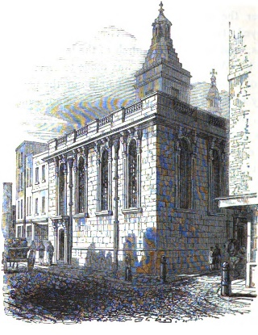Cemetery

In this assignment, you will use a real data set and determine some information from it. The data you will use is from the St. Mary Magdalene Cemetery on Old Fish Street in London. The burials recorded at this cemetery are from 1813-1853.

The first five entries of the data set are as follows:

ST MARY MAGDALENE OLD FISH STREET CITY OF LONDON

Burials 5th Jan 1813 - 10th July 1853

NAME BURIAL DATE AGE RESIDENTIAL ADDRESS

----------------------- ----------- --- ----------------------------

John William ALLARDYCE 17 Mar 1844 2.9 Little Knight Ryder Street

Frederic Alex. ALLARDYCE 21 Apr 1844 0.17 Little Knight Ryder Street

Philip AMIS 03 Aug 1848 1 18 1/2 Knight Rider Street

Thomas ANDERSON 06 Jul 1845 27 2, Bennet's Hill

Edward ANGEL 20 Nov 1842 22 Crane Court Lambeth Hill

**Objective**

Read in the data, clean the data to handle any inconsistencies, store the data in an array of Person objects, and then find and print the name and age of the youngest and the oldest people in the cemetery. Your application must work for any input file (without the first 4 lines) that is formatted like the entries above.

Note that each entry contains 4 items: name, burial date, age at death, and address. You will store first three items of information in a Person object. The first two values are Strings but age-at-death will be stored as a double. You are to ignore the Residential Address information.

1. What is the best way to extract the data from each line?
2. Write the fields and a constructor in the Person class.

Interestingly enough, the data for the deceased person’s age comes in a mixed format, depending on the information taken from the tombstones, either whole-number years (like 64), partial years (expressed in decimal format, like 0.17), the number of weeks (like 14w), or the number of days (like 4d). We need to convert all those mixed formats into a decimal number of years as shown below:

|  |  |
| --- | --- |
| String input | double value (no more than 4 digits) |
| 64 | 64.0 |
| 0.17 | 0.17 |
| 14w | 0.2685 |
| 4d | 0.011 |

After the array representing cemetery burials is filled with Person objects, find and print the name and age of the youngest and the oldest people in the cemetery.

**Example Input** (using cemetery_short.txt):

John William ALLARDYCE 17 Mar 1844 2.9 Little Knight Ryder Street  
Frederic Alex. ALLARDYCE 21 Apr 1844 0.17 Little Knight Ryder Street  
Philip AMIS 03 Aug 1848 1 18 1/2 Knight Rider Street  
Thomas ANDERSON 06 Jul 1845 27 2, Bennet's Hill  
Edward ANGEL 20 Nov 1842 22 Crane Court Lambeth Hill  
Lucy Ann COLEBACK 23 Jul 1843 14w Lambeth Hill

Thomas William COLLEY 08 Aug 1833 4d Lambeth Hill

Joseph COLLIER 03 Apr 1831 58 Lambeth Hill

**Example Output** (using cemetery_short.txt):

John William ALLARDYCE, 17 Mar 1844, 2.9  
Frederic Alex. ALLARDYCE, 21 Apr 1844, 0.17  
Philip AMIS, 03 Aug 1848, 1.0  
Thomas ANDERSON, 06 Jul 1845, 27.0  
Edward ANGEL, 20 Nov 1842, 22.0  
Lucy Ann COLEBACK, 23 Jul 1843, 0.2685  
Thomas William COLLEY, 08 Aug 1833, 0.011  
Joseph COLLIER, 03 Apr 1831, 58.0  
  
In the St. Mary Magdelene Old Fish Cemetery -->   
Name of youngest person: Thomas William COLLEY  
Age of youngest person: 0.011  
Name of oldest person: Joseph COLLIER  
Age of oldest person: 58.0

**Assignment**

The shell is called Cemetery.java. The driver has been written for you, but you will implement five class methods as well as override toString (details in the shell). You are also to design and implement the Person class.

**Extension**

Brainstorm ideas for other investigations using this data set. Program one of them.